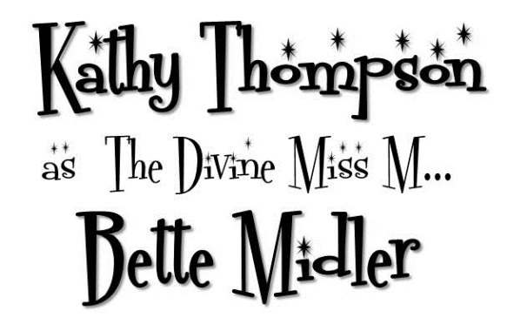
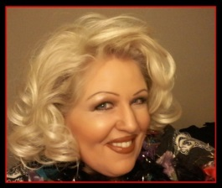
BIO / PRESS RELEASE

Kathy Thompson
as The Divine Miss M…
Bette Midler

Kathy will dazzle you as everyone’s favorite Diva - Superstar !

Since 1995, Kathy has delighted in portraying Bette Midler around the world, getting her start with Legends in Concert from Las Vegas. At the back of the room, owner John Stuart was overheard saying “She looks just like her.” during the audition.

Kathy has both the look AND the voice. Whether performing in a large showroom or at a unique small event, on the red carpet, as an emcee, at an opening, doing a comedy walk-about OR meet and greet, you’re guaranteed a good time! Kathy has been singing the hits of Bette Midler for more than twenty years on stages around the world. Being no stranger to standing ovations, audiences love her as they say over and over after performances during meet and greets. Kathy says, “Bette’s repertoire has something for everyone!” Big band swing era tunes, hip-hop, country, ballads, blues, dance songs and even some “Sophie” jokes for a good belly-laugh!
(See testimonials at: http://www.kathyasbette.com/testimonials )

The likeness Kathy has achieved as this legendary pop icons is remarkable. Her personal patter and mannerisms are just like the real Midler. But it’s the humor of the superstar’s dynamics and comedic timing which Kathy has captured that sets her show apart from others. Solid gold hits and lots of audience interaction leave guests laughing, reminiscing and feeling great!

As Bette, Kathy has cavorted in Branson at the Dick Clarke American Bandstand Theater and the Osmond Family Theater, in Mexico both in Cancun and Bucerias, Myrtle Beach, San Francisco, Bally’s & Trump Taj Mahal Atlantic City Millennium New Years, Japan, Detroit, in Berlin at the giant Estrel Hotel, Cologne, Mystic Lakes Minnesota, Basel-Switzerland, Utah, Las Vegas - Legends in Concert, Florida, “Escape from OZ” in Hamilton, Caribbean Cruise Ships, Mall of America, Banff-Alberta, Spa S/X-Toronto, Stage West Dinner Theatre, Woody’s, ‘The Docks’, Cedar’s, Cruise Line & Barrymore’s “Luv Ball” in Ottawa, and her one-woman Tribute to Bette Show in Hartford, Connecticut. Kathy was emcee and performer as Bette for her own Gala Fundraiser at the Enwave Theatre, Harbourfront to raise money for Animal Rescue in Toronto.

Kathy includes these songs in her Bette repertoire:
Boogie Woogie Bugle Boy, Wind Beneath My Wings, Stuff Like That There, I’m Beautiful, The Rose, In the Mood, From a Distance, You Don’t Own Me, Under the Boardwalk, I’m a W-O-M-A-N. . . “It’s The Girls” Doo-wop hits from the 60’s. You will also enjoy Bette’s tribute to martini-cool hits of the 50’s & 60’s from the ROSEMARY CLOONEY and PEGGY LEE songbook.
( More show songs listed at: http://www.kathyasbette.com/bette-song-list )

SOME CLIENT TESTIMONIALS:
2017 January, Mexico, FACEBOOK REVIEW:
"Another hot night at The Lounge. Kathy Thompson's sold out tribute to "The Divine Miss M" brought the house down. What style! What a sense of humor! And what a set of pipes! “

2016 August, Michigan, FACEBOOK REVIEW:
“At Sunday’s ‘Star Salute Matinee Show’ Tribute Artist Kathy Thompson, singer and entertainer, took the stage and gave a super tribute to the Divine Miss M… Bette Midler! Live vocals, comedy and great music… not to mention the great prime rib dinner…how lucky can we get! “

2015 May, Wisconsin Casino, Email:
" HI Kathy, Thank you for such a great performance, everyone enjoyed themselves! We will definitely keep you in mind for future shows! "

SOME REVIEWS:

Bette Midler mimic, Elton John Impersonator Enliven `Legends in Concert'
Fri, Feb. 13 - http://www.courierpostonline.com/columnists/cxda021304a.htmy
Chuck Darrow, Courier-Post Staff, South Jersey
Joining headliner James Lowry (as Elvis) are a quartet of fabulous fakes led by Kathy Thompson, whose portrayal of Bette Midler ranks among the best celebrity impersonations the local Legends franchise has ever offered. Thompson's physical resemblance to Midler is striking: She has the same toothy grin, blond locks and zaftig build as her subject, and she ably captures Midler's body language. Her right-on-target vocal impression enhances the illusion of Midler on the Palace Theater stage as she offers such signatures as "Boogie Woogie Bugle Boy of Company C," "I'm Beautiful" and a "The Rose"/"Wind Beneath My Wings" medley.

“When Kathy Thompson took the floor and made with the pipes, her talent was disarming
and a tough audience melted in record time. Pseudo-Midler, tribute singer, call her what you will, this gal can belt a song and on key. At times the resemblance was startling, from the sheer lung power to the good-time gal/gay-bonhomie schtick that the real Bette Midler does so well. In between there were twangy Midler inflections and camp demeanor, as she cracked wise with the guys and won over cynics with self-deprecation. Two words can account for Thompson’s success in pretending to be what she’s not: authority and generosity. The former she’s got in spades, just like the real Bette. The giving vein was there in her big smile; she was enjoying herself. She tapped into Midler’s energy and joy just for you singly and collectively and made us a gift of her voice.”
…XTRA MAGAZINE, TORONTO (Spa X/S)

Kathy looks & sounds so much like the real Bette….it’s SPOOKY.”
...THE BRANSON DAILY NEWS, BRANSON

“One of the best acts yet seen in Bally’s celebrity impersonation revue is Kathy Thompson, and she is just wonderful as Bette Midler. Clad in tight toreador pants and high heels, Thompson presents an excellent physical and vocal portrayal of the superstar. But she actually goes beyond mere mimicry. Her turn is so energetic & entertaining that she transcends simple impersonation The performance stands as a great piece of work in its own right.”
… WHOOT MAGAZINE, ATLANTIC CITY

